**`EUROPEAN UNIVERSITY OF LEFKE**

FACULTY OF ENGINEERING

Graduation Project 2

Online Auction System

### Titilope Niyi-Adesola

### 174376

**This project online auction system is a system where prospective buyers will be invited to the auction. There will be bidding that pushes the price higher to maximize the profit of the seller from the sale.**

**The reason why this system would be used is because it reduces the complexity that comes with live auctions. The goal of this system is to allow the users to be able to bid from their comfort**

**Supervisor**

Zafer Erenel

Publish Date

09/05/2021

Date

**Table Of Contents**

Titilope Niyi-Adesola i

174376 i

Zafer Erenel i

Publish Date i

09/05/2021 i

Date i

1.Introduction 3

1.1 Problem definition 3

1.2 Goals 4

2. Literature Survey 7

3. Background Information 12

3.1 Required & Used software 12

3.2 Other software 15

3.3 Hardware 15

4. Design Documents 16

4.1 Data flow diagram 16

4.2 Context Diagram 17

5. Methodology 25

6. Conclusion 43

6.1 Benefits 43

a. Benefits to users: 43

b. Benefits to me: 43

6.2 Ethics 43

6.3 Future Works 44

7. References 45

# 

# 1. Introduction

## The word "auction" stems from the Latin word “augment." An auction is a method of public trading where goods are sold to the highest bidder.

## There are various kinds of auctions, each with its own set of rules. An auction may have a variety of features, such as a minimum price limit, a maximum price limit, and time constraints, among many others. Bidders may join online or in person, depending on the auction method. Participating in a remote auction may be done by phone, mail, or the internet. Online purchase has become extremely prevalent, and the use of online auctions is growing substantially. Since online auctions are becoming more common in online shopping, the system's quality and functionality must improve. This online auction system is a system in which users bid for goods and services by placing a bid on each item of their preferred choice. The use of this online system is that it can control the processes involved in auctioning which makes auctions even simpler. There are different types of auction and this is based on the way it’s been performed and the English auction scheme is one of the most common methods. This system was designed to be highly scalable and capable of handling vast numbers of bidders in an active auction. Online Auction System can also be referred to as e-Auctions and electronic auction. The client's requirement for an online auction may be more precisely defined. When it is made clearer as a matter of fact, it should be safe and a positive practice.

This Online Auction System is based upon the highest price which is, among all bidders whoever bids with the highest price gets to win the bid and then offered best value for the product. Online bidding is becoming increasingly widely used in a variety of industries. It covers not only the product or items to be sold, but also the services that can be offered. The system grew as a result of its low cost growth. Online bidding has become a common approach for procuring goods and services. Bidders may be managed and stored in a single database, according to their preferences. For the legality and integrity of legal paperwork, user data might be kept secret. Clean reporting saves time and money by reducing paperwork, postage, and photocopying. Multiple bids may be easily interacted with. This method allows a single user to submit several bids in a current live bid.

## 1.1 Problem definition

This project Online Auction System is an online website that allows sellers put their goods up for auction and then bidders register in order to be able to bid on the product.

Since products are involved in the system, it is essential to create a system that provides the highest measure of protection. The system must provide buyers with exclusive bidding access. Users' registrations must be validated using their email address at the time of registration.

The first to make a bid is for the user to register and for this users must first enter their e-mail address, name, house address and phone number before they can register. After this detailed are been entered, they are automatically stored in the database so that the users can just login the next time. Each auction have a name, a description, a photo of the item been auctioned, the start time and end time and all this are uploaded by the admin. When the auction interval (start-end period) expires, consumers are unable to place bids; however, if there are no offers for an item, the interval may be extended if the admin wants. An admin have the access to be able create an auction, delete an auction, update information on an auction, set time for bidding, send notifications to registered bidders etc

When an auction is live the users which are also bidders try to outbid other bidders by quoting a higher price than the already stated price; finally the highest bidder currently wins the product at its current price. Users would find this project useful because it would them the comfort of having to bid any where they are and also makes it less tense since it’s not a live auction.

**Problems:**

* Bidders are uncertain about the product cause they can’t evaluate the product physically before acquiring it
* Since buying and selling is done online there’s no good relationship between bidders and sellers because bidders are unidentified
* Bidders have to wait for a certain time before acquiring a product
* There are possibilities of bidders to be scammed.
* The company might fail to deliver the goods to the winner of the auction even after the bidder has paid
* There might be a misrepresentation of the goods delivered

## Goals

The goal of this project is explained below

* To design and implement an online auction system.
* This system would enable user to register securely and they would be able manage their profile
* To provide bidders the comfort of bidding from wherever they are
* To enable bidders obtain the best value for the goods
* To be able to invite prospective buyers to the auction
* To maximize the profit of the seller from the sale

**A Use-Case Diagram for The Project**

A use case diagram is usually used to depict the functionality of a system from user's perspective. It focuses on the behaviour of the system from an outsider’s point of view

External factors that communicate with the system are referred to as actors. Users such as administrator, consumer, and seller are examples of performers. This Online Auctioning system, the actors that use it are the Admin and the Customer. The Admin will be able to login and if successful they would be redirected to the admin dashboard where they can add an item to the system, manage actions which are to create an auction, edit an auction and delete an action, see the list of all of the registered users, as well as the winner of a bid.

For customers they can sign-in if they have already registered if not they have to register first, after this they can search for an item, participate in a bid and if they win make payment for it. Lastly they can view their profile and edit it if need be.

<<extend>>

Bidder

Admin

# 2. Literature Survey

An auction is a market with a series of explicit rules for providing services and setting prices based on bids by buyers and sellers (McAfee & McMillan, 1987). In general, an auction is the most common method for systematically aggregating supply and demand in the economy to determine a price for a good or service. It sets prices for trading products based on bids from participants, and the products are sold to the highest bidder.

Simply put, an auction is a system for allocating scarce goods that relies on competition among the participants. It's the purest of businesses: a vendor needs to get the most value for the product they're selling, while a buyer wants to pay as least as possible for the same commodity. In a traditional auction, there are three participants: vendors, buyers, and auctioneers. When it comes to deciding market-based values, an auction has the benefit of being easy.

In a typical physical auction, a purchaser will choose an auction house based on the following factors: the type of licensing, the availability of appropriate insurance, appropriate descriptions and access to the products, payment conditions, and the quality of goods prior to and during the auction period. The buyer or seller shall attend the auction in person or send a representative. Participants can enter an online bidding scheme and place bids from anywhere at any time using a screen. The access is not only restricted to personal computers, but it also extends to mobile devices handheld gadgets, such as cell phones, are also included. Online auction sales are based on data (product descriptions), and products are only moved from seller to buyer after all online transactions are completed. They make it easy for buyers and sellers to interact, show items for sale regardless of their physical location, share information, and complete transactions.

Online auctions provide considerable convenience by allowing trading at specific time and providing constantly updated information and they enable buyers and sellers to exchange directly, bypassing conventional intermediaries and reducing prices for all parties. Online auctions have a global presence, giving shoppers a much larger range of items to choose from and sellers the chance to sell.

Online auctions have a global presence, giving buyers a much larger range of products to choose from and giving sellers the ability to sell their products to a larger audience.

Aspects that make online auctions appealing can also have drawbacks. Many online auctions just list the items that are available for purchase. There is no effort to validate and ensure that the item exists or that the description is correct. The two most serious issues are payment authenticity and stability.

Looking back into the definition of auction we can say auction is a public sale in which the particular good are sold to the highest bidder. There are different types of auction and this is based on the way it’s been performed. We have

* English auction
* Dutch auction
* First price sealed bid auction
* Second price sealed bid auction

**English Auction: -** it’s mostly used among the others. Here the goods for auctioning are put at a comparatively low price so that various bidders are then allowed to place their bid before the auction closes. This auction can be online or physical and this is where my project lies. These auctions last for a specific period of time, they might list for a couple of days or for a few hours. The auction ends when the time fixed for it elapses. The bidding is won by the highest bidder in this form of auction.

**Dutch Auction:-** this is slightly similar to the English auction but in this case the starting price is usually high then its gradually lowered as bidders start bidding and then agrees to buy it else it keeps going down till they reach a predetermined price. This can also be done online

**First Price Sealed Bid Auction: -** in this type of auction, all bidder bids once and the amount the bidders bid is kept a secret during the auction. The bids are then submitted without other participant knowing what they bid. The highest bid among the bids that were submitted wins and the bidder pays for the goods.

**Second Price Sealed Bid Auction:-** This is the same process as the first price sealed bid auction, but instead of the top bidder paying the price of the second highest bidder, the highest bidder pays the price of the second highest bidder. Online auctions have grown in popularity.

Online auctions have gained a lot of traction. eBay (www.ebay.com), one of the most popular internet marketplace sites, claims that the number of registered users globally grew from 27.7 million in 2002 to 41.2 million in 2003, with around 292 million listings (eBay, 2004). According to Nielsen/Netratings, the world benchmark for Internet audience measurement and analysis, eBay was also one of the top five platforms in Germany and the United Kingdom in February 2004 (Nielsen/Netratings, 2004). The Aberdeen Group discovered that auctions accounted for 94% of net retail purchases, while catalogue sales accounted for just 6%. (Pritchard, 2002). The majority of auctions are free to the general public. You'll be able to locate anything you're searching for. Given the online market's rapid growth, there are no de facto guidelines for the bidding rules and policies that regulate the online auction industry. Despite the fact that online auctions have been around for a long time, there are still two big issues: trustworthiness and security. Often auction sites refer to themselves as "meeting places for buyers and sellers" when it comes to the first issue, trustworthy transactions. They basically encourage sellers to post items for sale without ensuring that the seller is genuine or that the description is correct. They are the very ones that distinguish the buyers and sellers through the use of an email address which is why in this system not any one can be a seller. Following the auction, the seller which is our admin is responsible for dealing directly with the buyer about payment and distribution.

Online auctions are quickly becoming the preferred mercantile mechanism in the ecommerce business.An Online Auction system is one of those ecommerce businesses that allow bidders to be able to participate in a bid and purchase goods on any bidding platform.

In this system the admin creates an auction for a particular good and then those that want buy such product participate in the auction and whoever bids the largest price wins the bid.

**Existing Project**

So in this project I would be making reference to 3 already existing project which are quibids.com, Ebay and bidderboy.com

**Quibids :** quibids.com is an online American company based in Oklahoma City, Oklahoma, United States. It is a shopping website that works as an online auction with the bidding fees, often referred to as a penny auction. Once the user clicks on any of the product it automatically takes them to where they would register and then bid. And this bidding happens only for resident in USA How my project would differ from this existing system is that my system would be able to allow bidders bid from any part of the world not only from a particular country like this quibids

At quibids, there are practically hundreds of auctions every day, similar to a handful or tens of auctions on other pages. This automatically leads to a more enriching experience for bidders, and bidders have more options for what they will purchase. If you lose too much money in the auction process, you will get your money transferred to the full selling price of the item. If you're bidding for something you'd like to buy anyway, this is a perfect feature to have. It has representatives that respond to questions on their pages and websites, which is a beneficial move.

There are many options to upgrade the site, though there are a few disadvantages to consider. As quibids gets more popular their number of users also increases. But the number of items at the auction is not been increased. This implies that higher bidding activity and a higher gross profit for the company, which means a lot of people, are going to risk a lot of money.

Bidders would pay a large sum for delivery of the product they won which was not stated before the auctioning, making it more costly which should not be so.

Another unfavourable feature of the auction system is that when a bidder pays for bidding, they say they are virtual because they used the "Buy it Now" alternative, and it is unclear whether they are listed against potential "Buy it Now" options. If they want to make more sense to be around, this has to be seriously revised.

They prohibit bidders from winning more than three auctions a day, three auctions per month, and more than one high-cost item per month, as well as winning the same item twice in a month. These restrictions seem to be excessive. Penny auctions are intended to be entertaining, so the rules can be flexible in certain situations, such as for lower-value coupons or auction for bids sets.

**eBay Inc:** [www.ebay.com](http://www.ebay.com) is an American multinational e-commerce company that is based in San Jose, California Via its website, it conducts consumer-to-consumer and business-to-consumer transactions. Anyone can sign up to start selling on eBay without any prior knowledge or a complex business setup. Sellers without shops can also get a month's worth of free auctions under the fee structure. Many small-scale vendors have been drawn to this form of transaction over the years, but increasing fees and increased reviews and customer care expectations have frustrated many. Many customers like the ease of buying online on eBay. Many buyers from all around the world can use eBay's foreign shipping service.

eBay auctions are usually a great location to sell unique stuff or stuff you're not sure how much they're worth. This brand has a lot of competition, and people are eager to get their hands on it. You might only designate a price, but sometimes you might be selling the product without any gain. An auction will allow all interested parties to bid up the offer to ensure you get the best deal possible.

When you buy stuff on ebay, you aren't necessarily buying it from ebay because of the brand image and built-in confidence. You're purchasing it from a private seller. However, many buyers do not think of it that way and, subconsciously, want to purchase from a business they are acquainted with, in this case ebay. It protects both the seller and the buyer. If there is less chance of being robbed, scammed, or otherwise taken advantage of, there will be more buyers and sellers.

In as much as ebay is good to use there are some setback while using ebay. On ebay if a customer deals with a dishonest vendor, getting a refund will take a long time, particularly if the buyer needs to wait for PayPal to arbitrate the dispute. Scamming schemes are also popular on eBay, with users receiving fraudulent emails claiming their account will be disabled and redirecting them to a bogus login page and when a user signs in, his authentication information and identities are vulnerable to hacking.

Users who are uncomfortable with eBay's restrictive policies or with any issues they have faced are unable to express their dissatisfaction through this medium. As a result, there is a loss of contact, and users receive automatic email replies as a result of the lack of a direct communication contact.

eBay charges its sellers a service fee, a final cost charge, and extra fees such as additional images, subtitle fees, and borders to improve the visibility of their sales. Furthermore, ebay's only mode of payment is paypal, which is owned by ebay. For each sale, PayPal charges the vendor a fee. Any of these fees will discourage sellers, particularly if they remove their capital.

**Bidderboy:** bidderboy.com is an Indian online auction website from the western region of India. In this system after registering you need to make a form of payment by buying what they call credit, the credit is used to place a bid, so it’s how much credit you have in your account that would determine if you are qualified to place a bid on particular product. How my project would differ from this existing system is that my system you don’t need to deposit any form of money before placing your bid.

# 3. Background Information

Below are the software and hardware tools I would be using for this system.

## 3.1 Required & used software

* **HTML and CSS**

**HTML**

HTML is a markup language used to describe webpages

HTML stands for Hyper Text Markup Language

A markup language is a set of markup tags that represent HTML documents.

Each HTML tag represents the content of a different document.

**CSS**

CSS is a style sheet language that specifies how an HTML document is displayed. It specifies how items can appear on a computer, in screen, or in other media.

The below are some of HTML's benefits:

Highly Flexible

User Friendly

Site built with are easy to maintain

There is no load on the server.

Validation.

Easy to use

* **PHP:**

PHP is also known as Hypertext Pre-processor programming language that aids web developers build dynamic software’s that connects to the databases.

I choose this language because it has so many great features which I’ll list below

PHP is a commonly used, open source scripting language.

PHP scripts are run on the server.

PHP can generate complex web material.

PHP can build, open, interpret, write, uninstall, and remove files on the server.

PHP can capture form data.

PHP can submit and retrieve cookies.

PHP can add, erase, and change data in the systems database.

PHP has the ability to monitor user access and encrypt data.

The below are some of PHP's benefits:

PHP runs on various platforms (Windows, Linux, Unix, Mac OS X, etc.)

PHP is compatible with almost all servers used today (Apache, IIS, etc.)

PHP can work with a variety of databases. (Apache, IIS, etc)

PHP is a free programming language. It's available for download from the official PHP website.

PHP is a server-side scripting language that is simple to understand and use.

* **BOOTSTRAP FRAMEWORK:**

Bootstrap is the most widely used HTML, CSS, and JavaScript platform for creating mobile-first, responsive websites. Bootstrap is an open-source series of frameworks for building websites and mobile apps that is entirely free to download and use. It includes design templates for typography, shapes, buttons, navigation, and other interface elements that are built on HTML and CSS, as well as optional JavaScript extensions. Its aim is to make developing interactive websites and mobile apps easier.

Unlike server-side programming, which exists on the "back end" or server, Bootstrap is a front end platform, that is, an interface for the user. While some of these browsers are not supported on all platforms, Bootstrap is compatible with the newest versions of Google Chrome, Firefox, Internet Explorer, Opera, and Safari.

* **MYSQLI**

MySQL is a Relational Database Management System (RDBMS)

MySQL is a fast, easy-to-use relational database management system (RDBMS) that is used by many small and large businesses.

MySQL is a free and open-source database. As a result, I would not have to spend anything to use it.

MySQL is an extremely efficient program in and of itself. It can accommodate a significant portion of the features found in the most costly and efficient database services.

MySQL makes use of a standard version of the widely used SQL data language.

MySQL is compatible with a wide range of operating systems and languages, including PHP, C, C++, JAVA etc.

MySQL is a fast database that performs well even with large amounts of data.

MySQL is very responsive to PHP, the most used web development language.

MySQL can handle massive databases of up to 50 million rows in a table.

MySQL is adaptable.

* **SUBLIME TEXT :**

Sublime Text is a third-party software download that is a cross-platform source code editor with a Python Application Programming Interface (API). It comes with support for a number of programming and markup languages out of the box, and users may extend its functionality by installing plugins, which are generally community-developed and maintained under free-software licenses.

* **PhpMyAdmin :**

PhpMyAdmin for database. it is a free and open source for MySQL. It is one of the most common MySQL management tools, particularly for web hosting services, as a portable web application written primarily in PHP.

* **XAMPP:**

Helps me to be able to run the website on a local web server

## 3.2 Other software

* **Git :**

Used for repository.

## 3.3 **Hardware**

* Processor –Core i3
* Hard Disk – 5 GB
* Memory – 6GB RAM
* System Type - 64-bit Operating System

# Design Documents

For the development of this system 4 design were created which were

1. Data Flow Diagram
2. Context Diagram
3. UML Model Diagram
4. Sequence Diagram

## Data Flow Diagram

Data flow diagrams (DFDs) can be used to represent data processing in a system. As data travels through a system, these depict the processing phases. In this system i would have 2 data flow diagram, 1 for the admin and 1 for the user.

## Data Flow Diagram for users

Over here there are 3 processes which are Register, Participate in Bid and Update Profile and then we have the data store which is the user’s database and the external agent which is the bidder.

**Level Zero Diagram**

1

Register

Enter details

Acknowledgement

Bidder

Sends details

Edit details

|  |
| --- |
| Users database |

3

Update Profile

Acknowledge bid

Summit bid

2

Participate in Bid

**Level 1 Diagram 1**

For the level 1 diagram this system has 2 processes which are the login and forgot password. A bidder must login and that requires entering the login details and if correct it logs the bidder in. A bidder is likely to forget their password and for that the user would Inputs new password and then the details would be sent to the database.

1.1

Login

Enter Details Send Users details

Logs users in

Bidder

|  |
| --- |
| Users database |

Store details

Inputs new password

Changes password

Updates new password

1.2

Forgot Password

**Level 1 Diagram 2**

In level 2 we have 4 processes which are Live bid, Upcoming bid, Closed bid and Submit Bid with 1 data store which is Bids database and the external agent in this system is the bidder.

2.4

Submit Bid

2.1

Live bid

Enters amount

Displays live bid

Store amount entered

2.2

Upcoming bid

Bidder

|  |
| --- |
| Bids database |

Displays Upcoming bid

Displays Closed bid

2.3

Closed bid

**Level 1 Diagram 3**

In level 3 we have 2 processes which are Update personal details and Update Password with 1 data store which is users database and the external agent in this system is the bidder.

Inputs name

3.1

Update personal details

Inputs email address

Inputs password

Bidder

Inputs Phone number

Inputs address

Stores details

3.2

Update Password

|  |
| --- |
| Users database |

Stores passwords

**Level Zero Diagram**

For the level 0 diagram this system has 3 processes which are the Users, Items and Auction. An Admin must login and that requires entering the login details and if correct it logs the bidder in. A bidder is likely to forget their password and for that the user would Inputs new password and then the details would be sent to the database.

1

Login

2

Users

Manage Users

Admin

Sends details

Manage Auction

|  |
| --- |
| Users database |

4

Auction

Manage Items

3

Items

Store auction details

Store item details

|  |
| --- |
| Auction database |

|  |
| --- |
| Items database |

**Level 1 Diagram 1**

For the level 1 diagram this system has 2 processes which are the login and forgot password. A bidder must login and that requires entering the login details and if correct it logs the bidder in. A bidder is likely to forget their password and for that the user would Inputs new password and then the details would be sent to the database.

1.1

Login

Enter Details Send Users details

Logs users in

Admin

|  |
| --- |
| Admin database |

Store details

Inputs new password

Changes password

Updates new password

1.2

Forgot Password

**Level 1 Diagram 2**

In level 2 we have 3 processes which are List users, Add users, and Delete users with 1 data store which is Users database and the external agent in this system is the Admin.

2.1

List users

Displays list of registered users

2.2

Add users

Admin

|  |
| --- |
| Users database |

Add users to the system Stores user’s details

Delete users from the system

Remove users from the database

2.3

Delete users

**Level 1 Diagram 3**

In level 3 we have 3 processes which are List items, Add items and Delete items with 1 data store which is items database and the external agent in this system is the Admin.

Items database and the external agent in this system is the Admin.

3.1

List items

Displays list of items

3.2

Add items

Admin

|  |
| --- |
| items database |

Add items to the system Stores items details

Delete items from the system

Remove items from the database

3.3

Delete items

**Level 1 Diagram 3**

In level 3 we have 3 processes which are List Auction, Add Auction and Delete Auction with 1 data store which is Auction database and the external agent in this system is the Admin.

Auction database and the external agent in this system is the Admin.

3.1

List Auction

Displays list of Auctions

3.2

Add Auction

Admin

|  |
| --- |
| Auction database |

Add users details to the system Stores Auction details

Delete users from the system

Remove users from the database

3.3

Delete Auction

## Context Diagram

This Context diagram is used to demonstrate the system's functional context; it demonstrates what lies beyond the system's boundaries. The users and the Admin are this systems functional context. The user can login/register on the system then the system would verify the details, then they can place a bid and update their profile.

The admin can login to the system then the system would verify the details and then they would create an auction, edit auction details and send confirmation of bid.

**Admin**

**Users**

**Online Auction System**

Enter Details Enter Details

Verify Details Verify Details

* 1. **UML Class Diagram**

The next step in the design process is to create a system UML Class Diagram. An UML Class Diagram is well-suited to displaying the system's entities, their interrelationships, and the classes' operations and attributes.

The project's class diagram is explained below.

The class **user** has parameters that include information about anyone that uses the system, the parameters include name, email, password etc. and the parameter role is a flag that differentiates the bidder from an admin. It performs the operation of a bidder which is to participate in a bid, make payment and edit their profile and also performs the operation of an admin which is to add an item, delete an item, add an auction, update an auction, list users and send messages.

The class **item** has parameters that include a variety of information concerning the auction item. The parameters include name of the item, price of the item and the image. As well as which auction item to which it belongs. An auction item has an auction ID, an item ID, the quantity that wants to be auctioned, the starting price and the order Number.

The class **bid** has parameters include a variety

**User**

-id: int

-name: string

-email: string

-mobile: string

-address: string

-password: string

-role: string

+placeBid(): void

+viewProfile()

**Item**

-id: int

-name: string

-price: double

-image: string

**Auction items**

-id: int

-auctionID: int

-itemID: int

-quantity: int

-startPrice: decimal

-orderNo: int

**Bid**

-auctionItemID: int

-userID: int

-amount: decimal

**Auctions**

-id: int

-startTime: time

-status: enum

**Admin**

-name: string

-email: string

+ createAuction()

+ editAuction()

+ deleteAuction()

+ addItem()

+ editItem()

+ deleteItem()

+ addUsers()

+ editUsers()

+ deleteUsers()

+ sendMessage()

* 1. **SEQUENCE DIAGRAM**

**This is a sequence diagram of a bidder when trying to bid**

The first this a user should do is either to register if they haven’t registered before or log in if they have registered before that’s why Login **/** Register is in an alternative box. Once the bidder clicks the submit button the system sends the details to the web server and then the web server interacts with the database by verifying the details been given by the user. Once the details are correct the web server logs the bidder into the system and then displays the home page.

The user then sees the auctions he/she wants to participate in; they now enter an auction, the system send the amount entered to the web server and then the web server communicate with the database to verify if the amount entered isn’t less than the current price, if the amount is validated, the web server returns the result and the system displays it to the screen as the current price.

The web server eventually closes the auction when the times lapses and then updates auction items.

**bidder**

**:WEB SERVER**

**:DATABASE**

**:AUCTION SYSTEM**

alt

Login

Register

Send Login Details

Verify Details

Return Details

Logs User In

Display home page

loop

Enter an Auction

Sends Bids

Verify Amount Entered()

return Result

Displays current price

Close Bids

Update Auction Items

**This is a sequence diagram of an admin creating an auction**

An admin must first login in order to access the dashboard of this system, once the admin clicks the submit button the system sends the details to the web server and then the web server interacts with the database by verifying the details been given by the admin. Once the details are correct the web server logs the admin into the system and then displays the dashboard.

Creating an auction the admin must first add an item to the system, the admin Clicks on “add item” the system displays the add item page and then the admin enters the items information, after that the system sends the information to the database and it’s then saved on it.

**DATABASE**

**WEB SERVER**

**AUCTION SYSTEM DASHBOARD**

**ADMIN**

Logs in

Send Login Details

Verify Details

Return Details

Logs admin In

Display dashboard

Clicks on “add item”

Displays add item page

Enter item information

Verify information

Stores information

Returns Information

Displays item information

Clicks on “add auction”

Displays add auction page

Enter auction information

Verify information

Stores information

Returns Information

Displays item information

# Methodology

This project is an online auction system where auctioning take place. This system comprises of two modules which are for the admin and the bidder. When registering a user can either log in as an admin or a bidder, if he/she logs in as an admin they would log in with their email and password but if the user logs in as a bidder then he would also need to log in with their email address and password. The system differentiates the login by their role. Both module operate differently

## 5.1Admin Module

We used MySql as the database and PHP as the server in the backend. The queries were written in MySql, then imported into PHP and connected to the application's front end. MySql is a versatile database language for storing, organizing, and accessing records data with ease

In this project admin are also referred to as the sellers. This is the admin dashboard of this system, this module is used by the admin and can be accessed only if the admin logs in with his email address and password.

The role of an admin is listed below

* Login
* Add an item to the database
* List an item
* Delete an item
* Edit an item
* List registered users
* Add users
* Edit users detail
* Delete a user
* List an auction
* Add an auction
* Delete an auction
* Edit an auction
* Send notifications to registered bidders

This is the general view of the dashboard

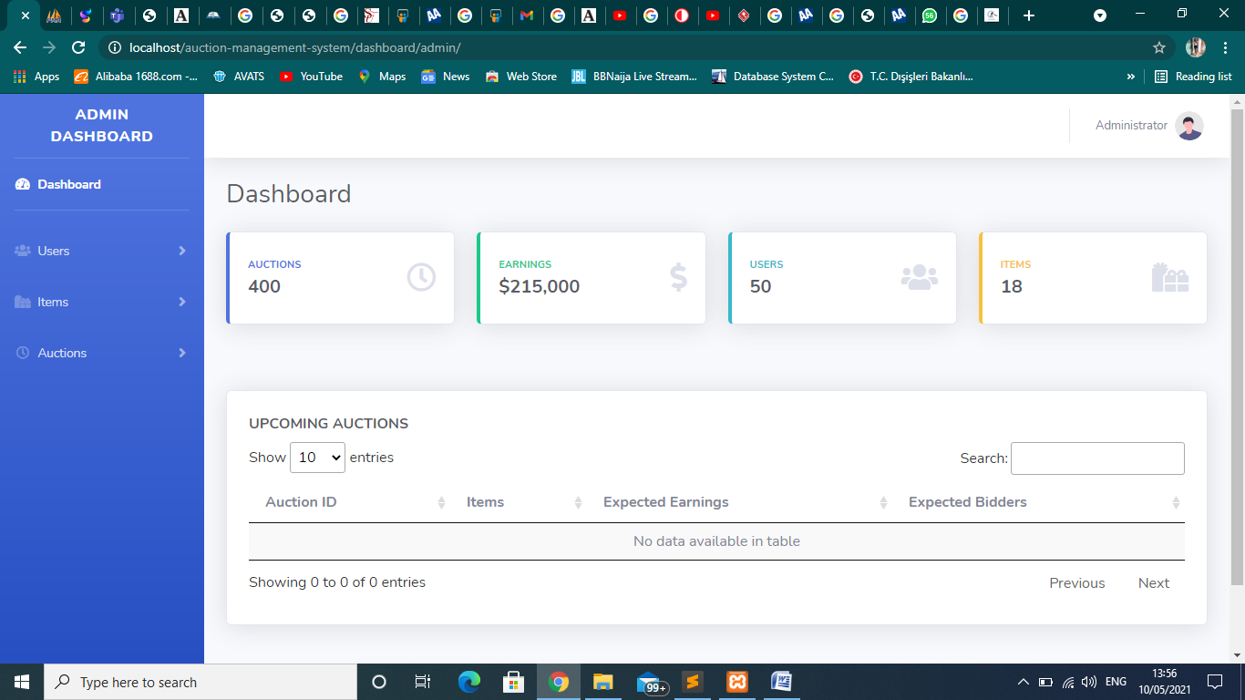

**Login**

For the seller to be able to access the system they would have to login first with their email address and password. Here the password are encrypted both in the database and also when typing. Once the details are authenticated they would have access to the system.

Below is the login page

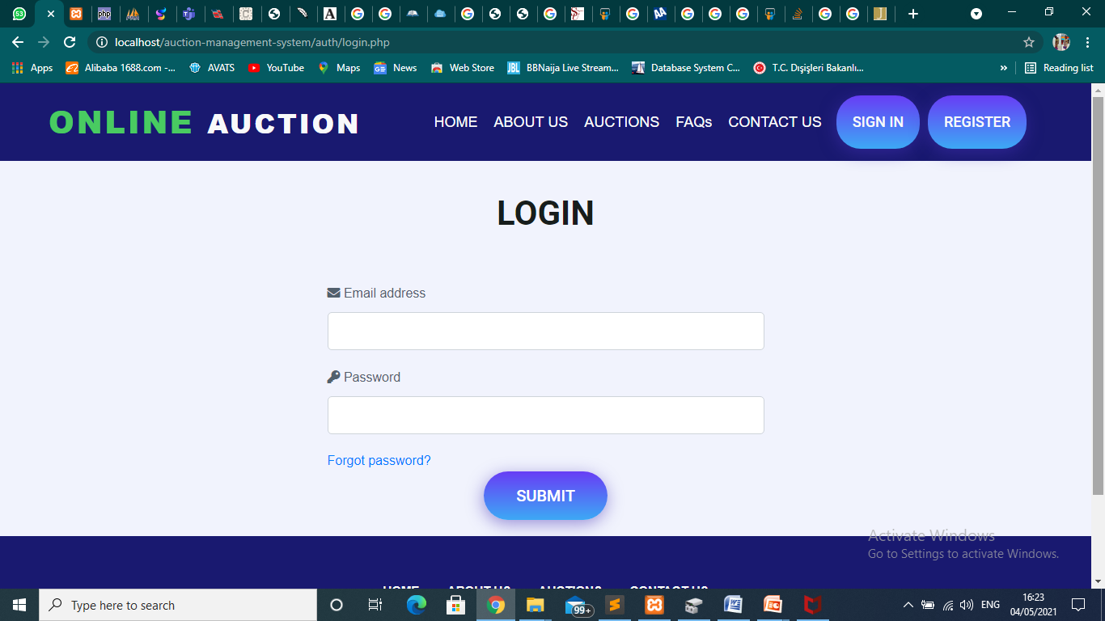

**Add an item to the database**

Before an auction is created the admin has to add the item to the database and by doing that they have to input the name of the item, the price of the item and then the image of it. Once the admin inputs all this and then click on the submit button it automatically saves the item in the database

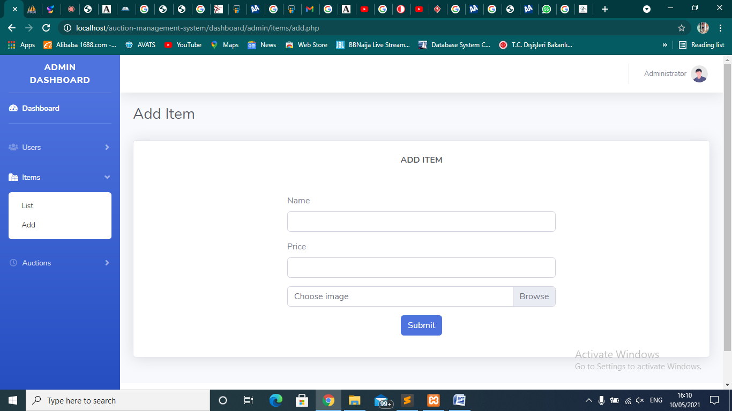

**List an item**

When the admin clicks on the list button, a table is being displayed. It contains the **ID** of each item, the **Name** of each item, the **Prices**, the **Images** and the **Actions** which include the edit button and delete button

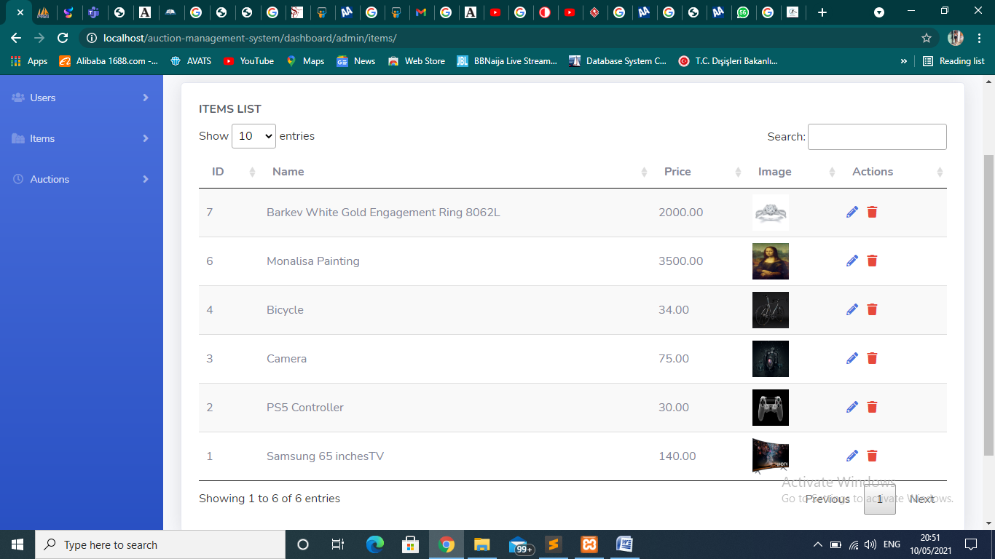

**Delete an item**

There’s a delete button for each item so when the admin clicks on the **Delete** button it deletes the item from the dashboard and the database too.

**Edit an item**

There’s an Edit button for each item so when the admin clicks on the **Edit** button it Edits the item information which includes the name of the item, the price of the item and the image of the item and when the admin edits the items information it updates the information on the dashboard and the database too.

**List Registered Users**

This module allows the admin to be able to see the list of all registered users. The table shows the **ID** of each user, their **Name**, their **Email** **Address**, their **Phone** **Number**, their **Address** and the **Actions** which include the edit button and delete button

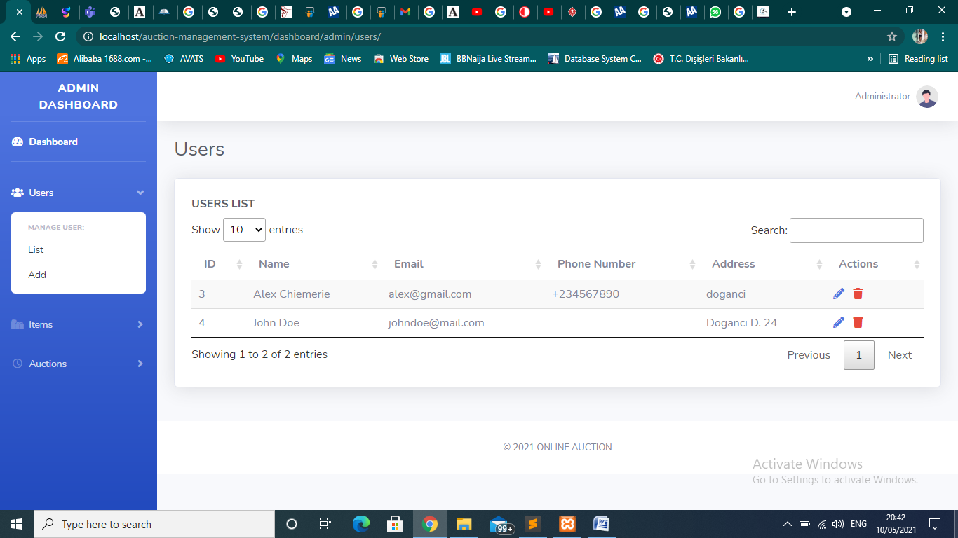

**Add users**

Through this dashboard an admin can add a non registered user to the system by clicking the add button and filling in the registration details which are the name of the user, the email-address of the user, the phone number of the user, the address of the user and password for the user

**Edit users detail**

An admin can edit the details of an already registered user by clicking on the **Edit** button. And once done the edited details will be updated in the database and on the system.

**Delete a user**

There’s a delete button for each users so when the admin clicks on the **Delete** button it deletes the user from the system and on the database too.

**List an Auction**

The list of an auction can be displayed when an admin clicks on the list button. This button displays on a table the id of each auctions, their start time, the number of items that want to be auctioned and the **Actions** which include the edit button and delete button.

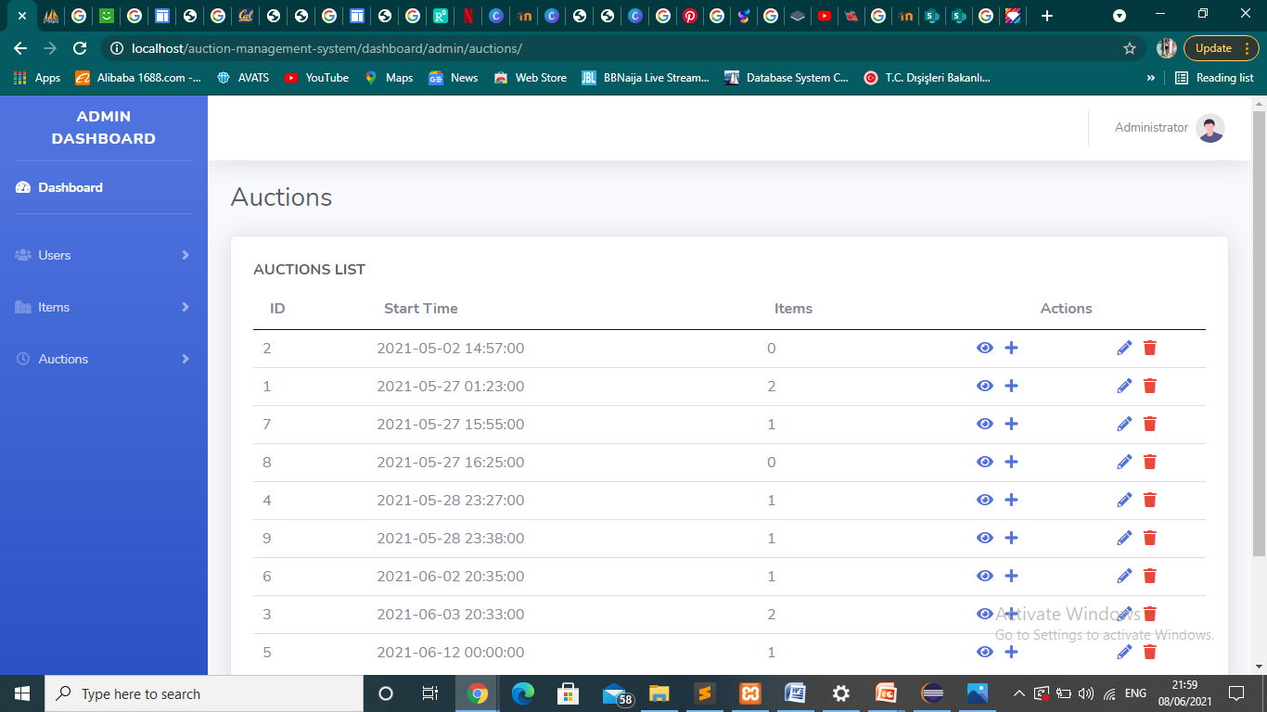

**Add an Auction**

It’s the work of an admin to add an auction to the system and to the database too. In order for this to be done the admin just have to put the start date for the auction

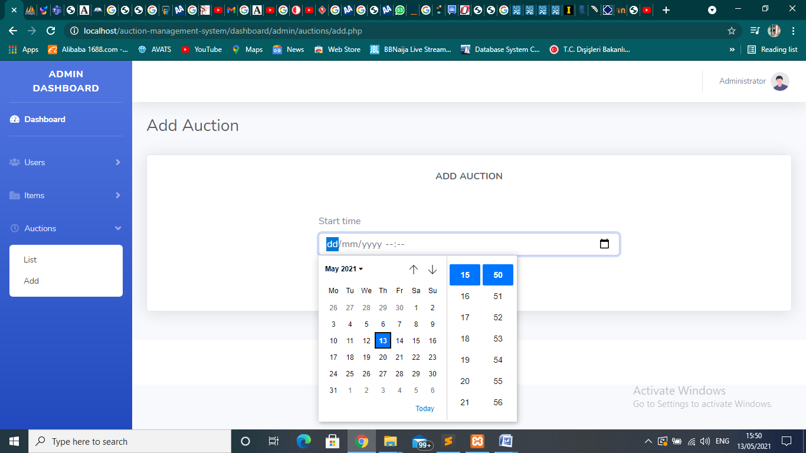

And when this is done the admin would the click on the list button, when the list page is opened they would now click on the **+** icon an then fill the form which includes them selecting the Item, stating the Start Price, the Quantity and the Order Number. The Auction ID greyed out is automatic the admin can’t edit it.

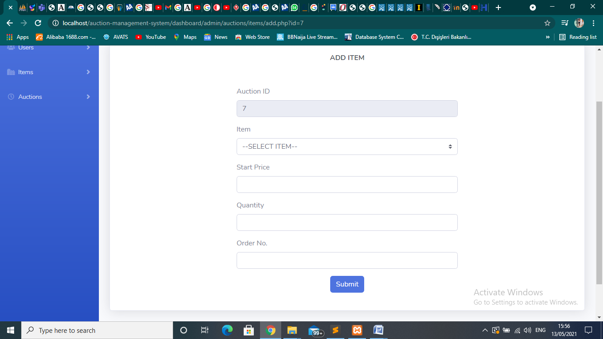

**Delete an Auction**

Whenan admin wants to delete an auction there’s a delete button for each action in the list page so when the admin clicks on the **Delete** button it deletes the auction from the system and on the database too.

**Edit an Auction**

There’s an Edit button for each item so when the admin clicks on the **Edit** button it Edits the specific auction information which includes the start time and the status it updates this information on the dashboard and the database too.

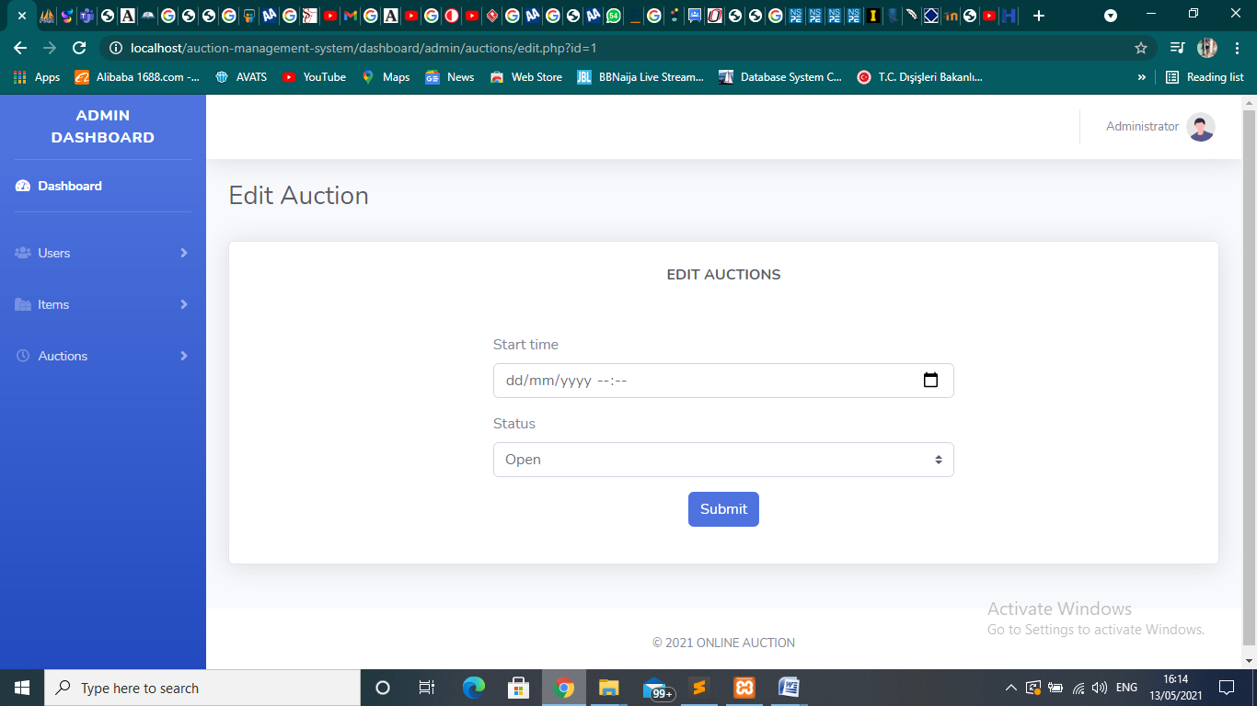

## Bidder Module

## This is the front end of this system; the front end of this system was designed using HTML CSS and JAVASCRIPT, allowing us to create a real-time auction system. CSS and HTML tags are used to design the system. BOOTSTRAP was used to design the system for smaller and larger device which allows our user to be able to use this system with their mobile devices.

## This module is used by the bidder and can be viewed by everyone, and they can see the auction that’s currently live, the upcoming auction, the closed auction, the starting for the auction that would be on auction, the product that would be available for bidding and details for each product.

## If a bidder wants to participate in a particular auction he clicks on the Submit bid button if the bidder isn’t logged in they’ll be redirected to the login page where they would be then requested to register by filling the following details (name, email-address, phone number, address and password) and if the user is already registered in the system then the user would just need to login by inputting their email address and password.

## Once the bidder has successfully logged in they would be redirected to the home page or the bidding page of the item they clicked where bidding would occur. In this room all the bidders who wants to bid on the current product would be able to bid by typing the amount they can afford and the highest amount would be displayed at the top and for every time a bidder bids higher than the current displayed price the displayed price would be changed and this would keep happening till someone wins the bid

## When the time of the auction is over the current highest bidder wins the bid and then a notification would be sent to the bidder to notify him/her that they have won the bid.

## A bidder can perform the following

* + - Register
    - Login
    - Participate in a bid
    - Update profile

**Register**

For the bidder to be able to access the system they would have to first register by inputting their name, email-address, phone number, address and password and then click the submit button, then the submit button would verify the details been entered and then save it in the database

Below is the registration page

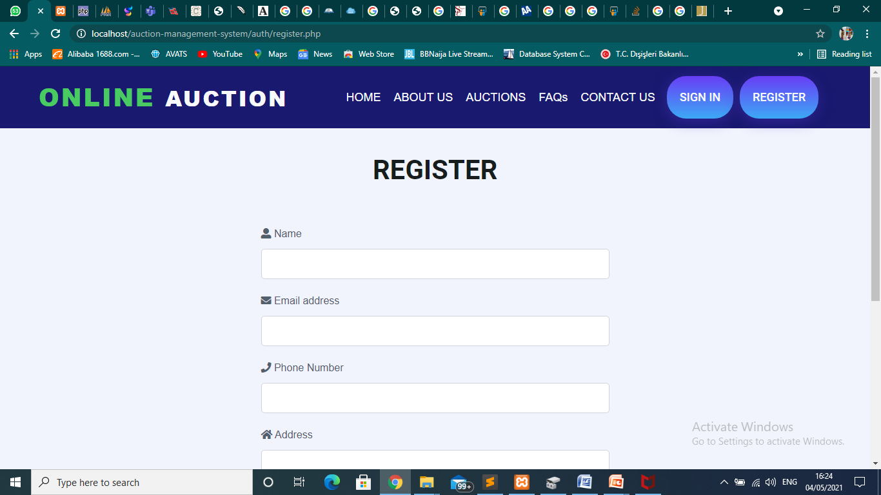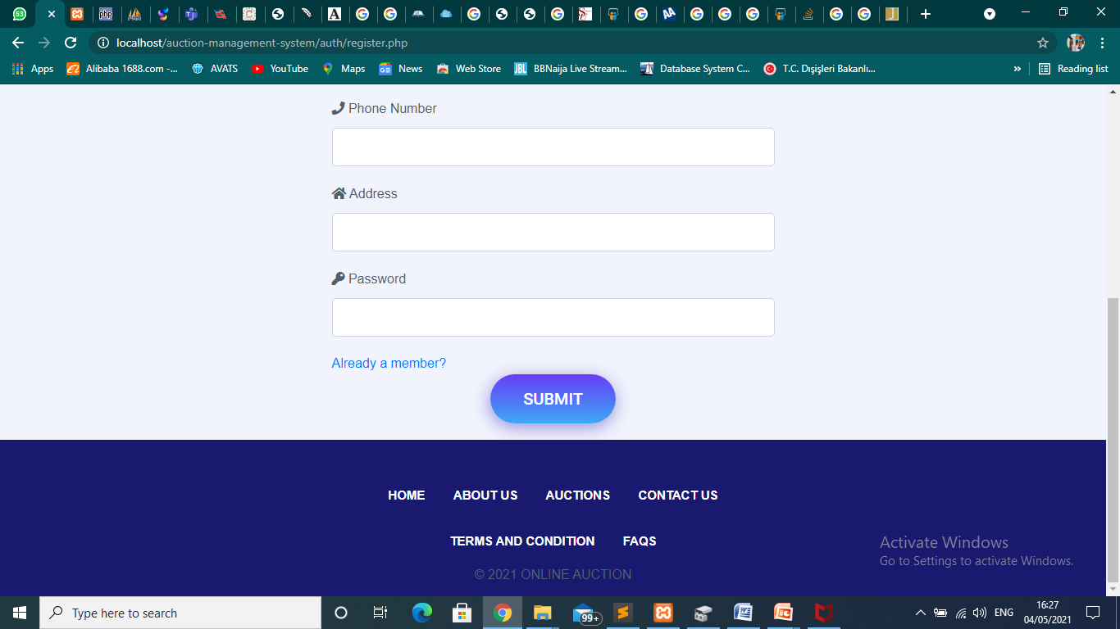

**Login**

For an already registered bidder to be able to place a bid they would have to login first with their email address and password. Once the details is authenticated they would have access to the system and then participate in the bid, view their profile etc.



**Participate**

In this sub-module the user can participate in a bid clicking on the submit Bid button and then they’ll be redirected to another page where the particular item would displayed and they’ll see the current price and price it started at.

The user can’t enter an amount lesser than the current price being displayed else an error would be displayed as shown in the image below.

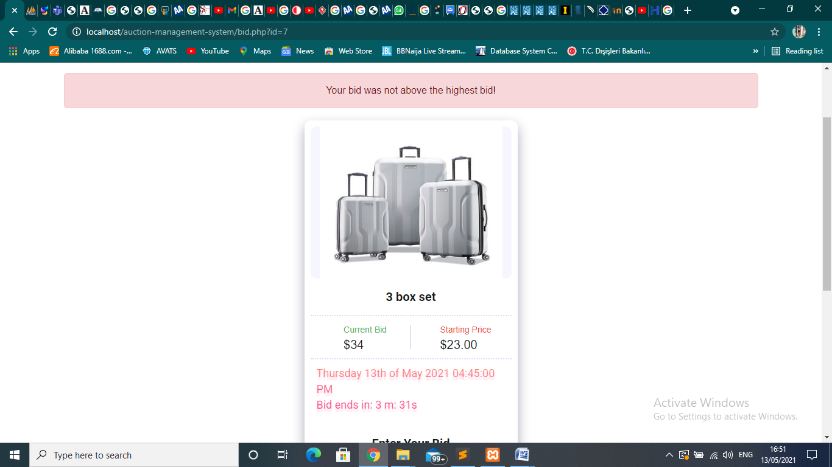

A bidder can only input an amount greater than the current bid price. A bidder can keep updating the price as the bidding is still in progress which would be within the time frame in order to win. At the end of 10 mins the auction would close and the highest bidder would be notified of his/her win.

Users Dashboard

When a user in this case a bidder clicks on the Dashboard button they’ll be redirected to a page shown below

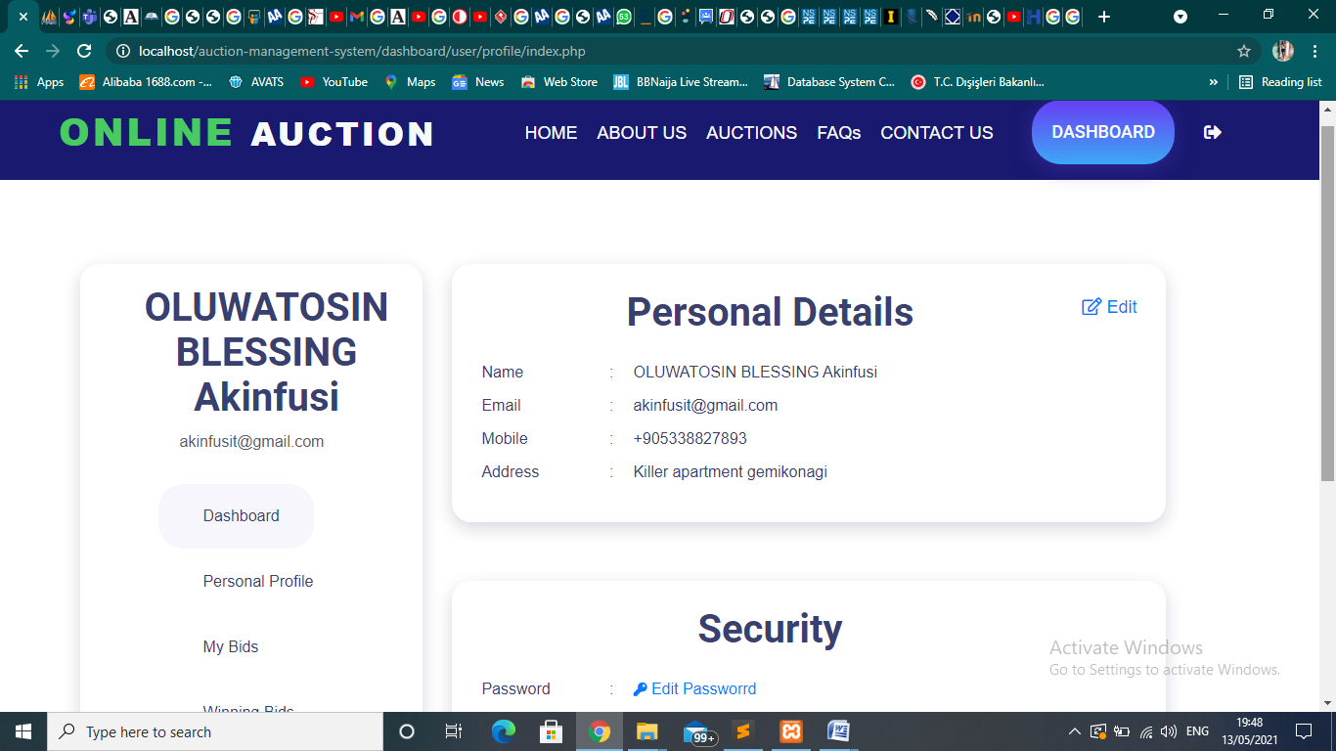

The Personal Details section contains the name of each registered user, their email, their mobile and their address.

The Security section contains their password

Each of this section can be edited, and if the user clicks on the Edit button for the Personal Details section a form with their current details will be displayed as shown below

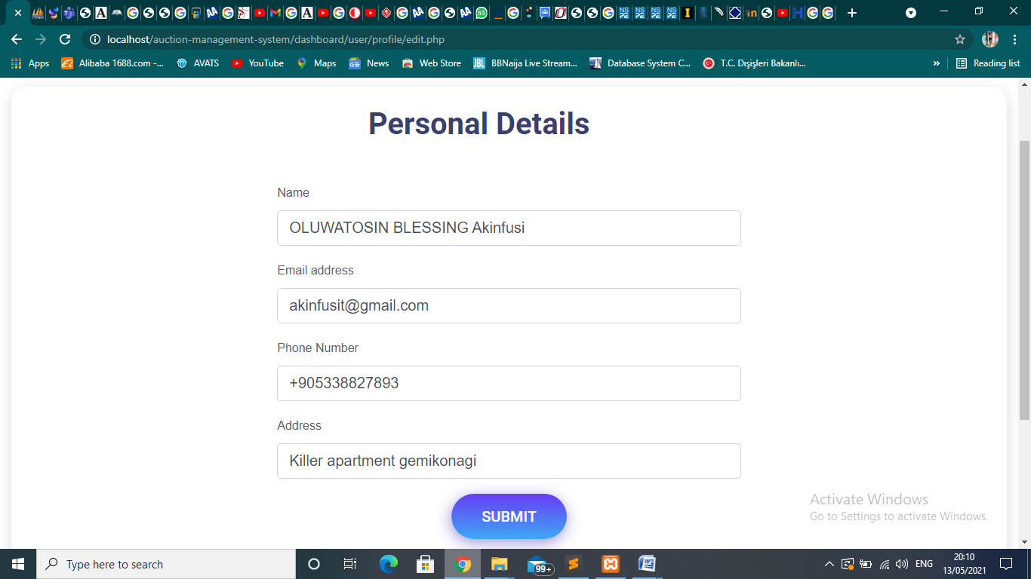

So they’ll just edit the part they want and click the submit button and the details would be updated on the dashboard and the database too.

If a user wants to change their password and they click on the edit button on the for the Security section they would be redirected to this page where they can change their password.

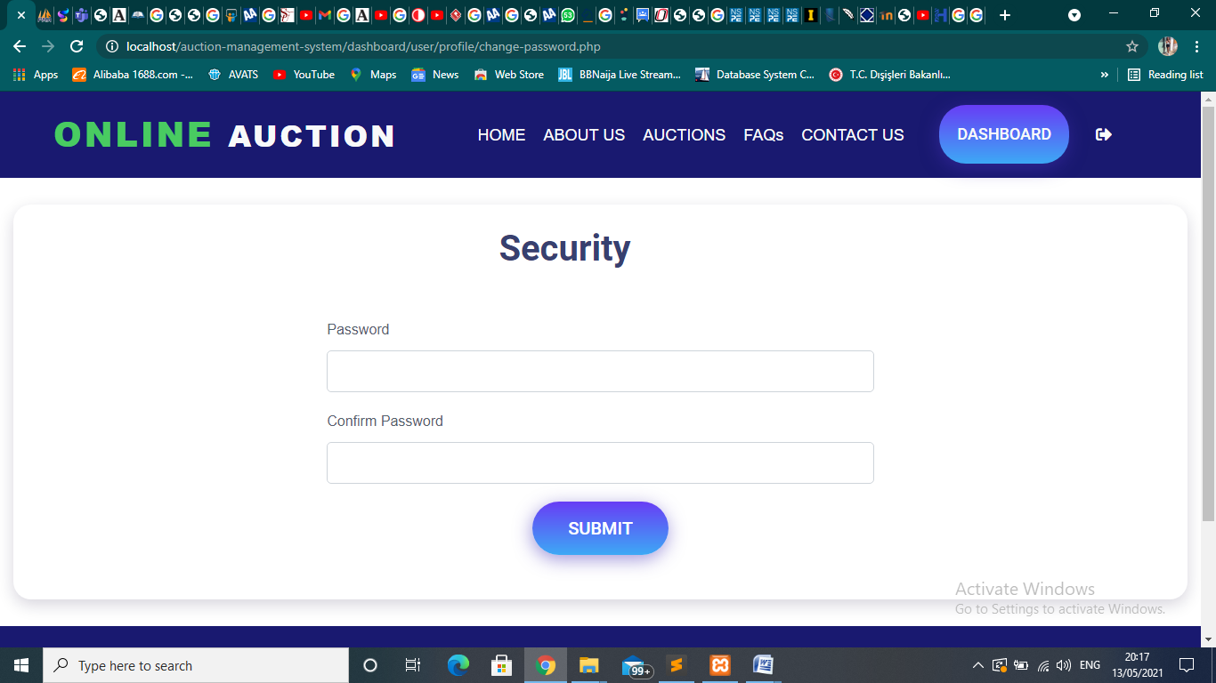

DATABASE OF THE SYSTEM

The name of the database of this system is auctiondb and it comprises of 5 tables which are the

auctions,

auctions_items,

bids,

item and

users.

We needed a database for this system because the details of our users need to be stored and a dataset is the right place.

The database has been normalized and is structured so that users do not experience any problem. To keep track of everything, five tables were needed. The primary/foreign key relationships are then established, resulting in legitimate transactions being filled in the tables.

The table's design can be seen below.

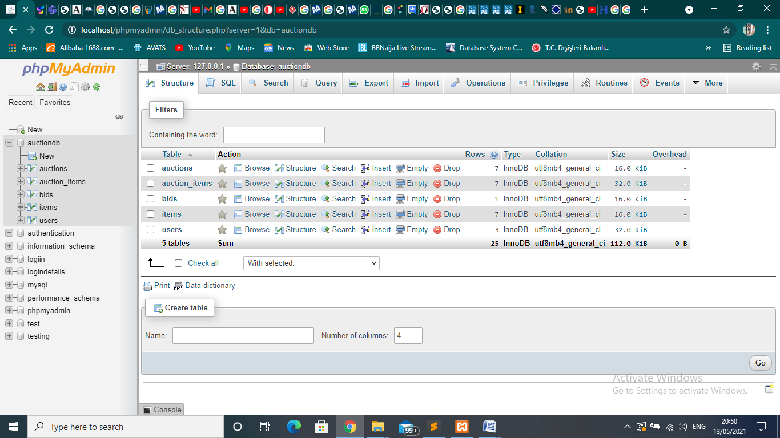

**A**uctions table:

This table is used to store the information of each auctions, it consists of 3 columns which are id, startTime and status.

The id is a primary key and i made it a primary key so that each auction should not have

|  |  |
| --- | --- |
| id | int(11) primary key |
| startTime | datetime |
| status | enum(‘open’, ‘closed’ |

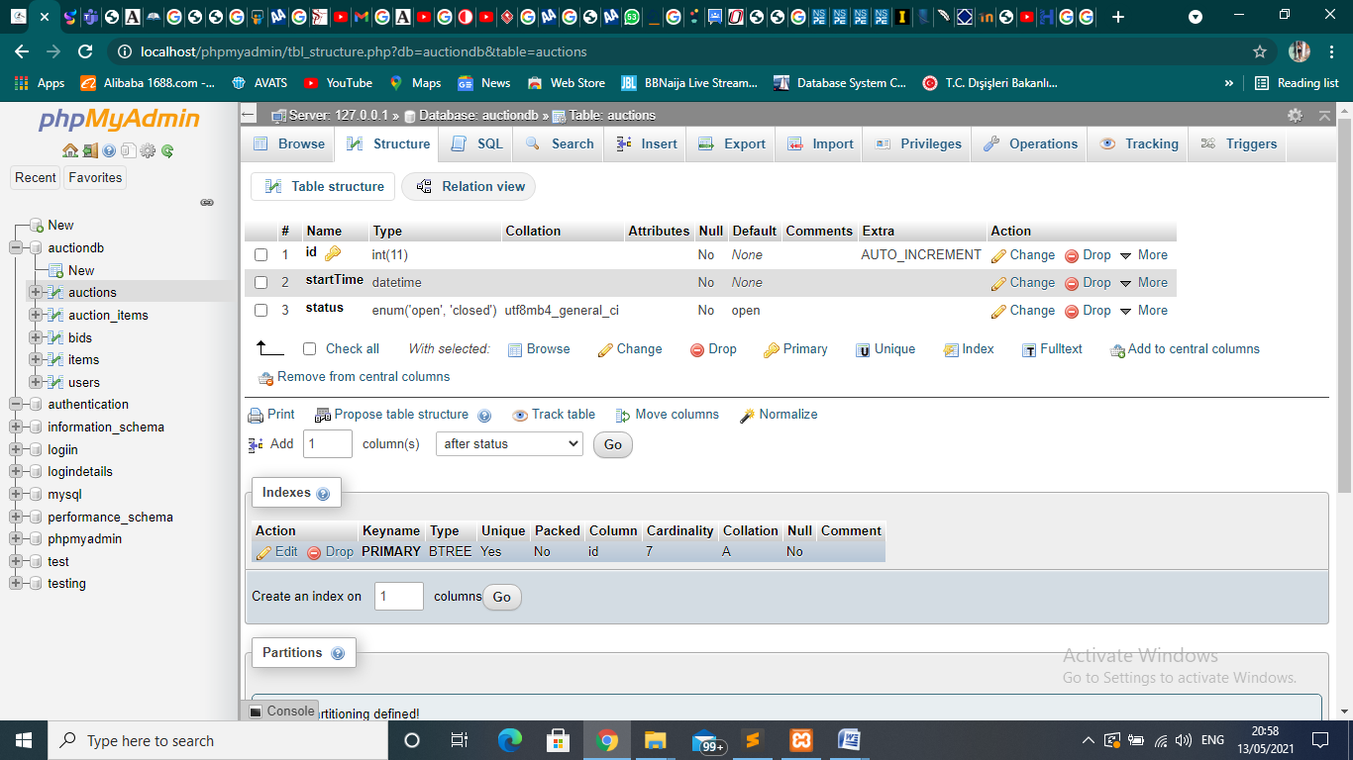

**auctions_items Table**:

This table is used to store the information of all items that are going up for auctioning, it consists of 6 columns which are id, auctionID, itemID, quantity, startPrice and orderNo.

|  |  |
| --- | --- |
| id | int(11) index key |
| auctionID | int(11) primary key |
| itemID | int(11) primary key |
| quantity | int(1) |
| startPrice | decimal(11,2) |
| orderNo(order number) | int(11) |

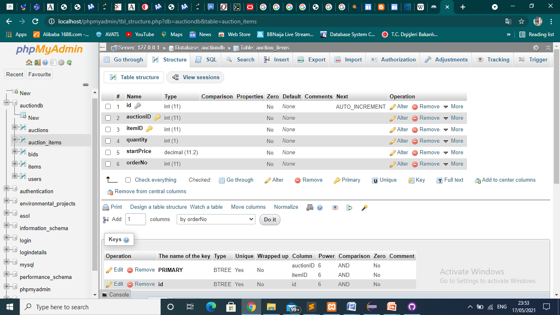

**bids Table:**

This table is used to store the information of all items that are going up for auctioning, it consists of 3 columns which are auctionID, itemID and amount.

|  |  |
| --- | --- |
| auctionID | int(11) primary key |
| itemID | int(11) primary key |
| amount | decimal(11,2) |

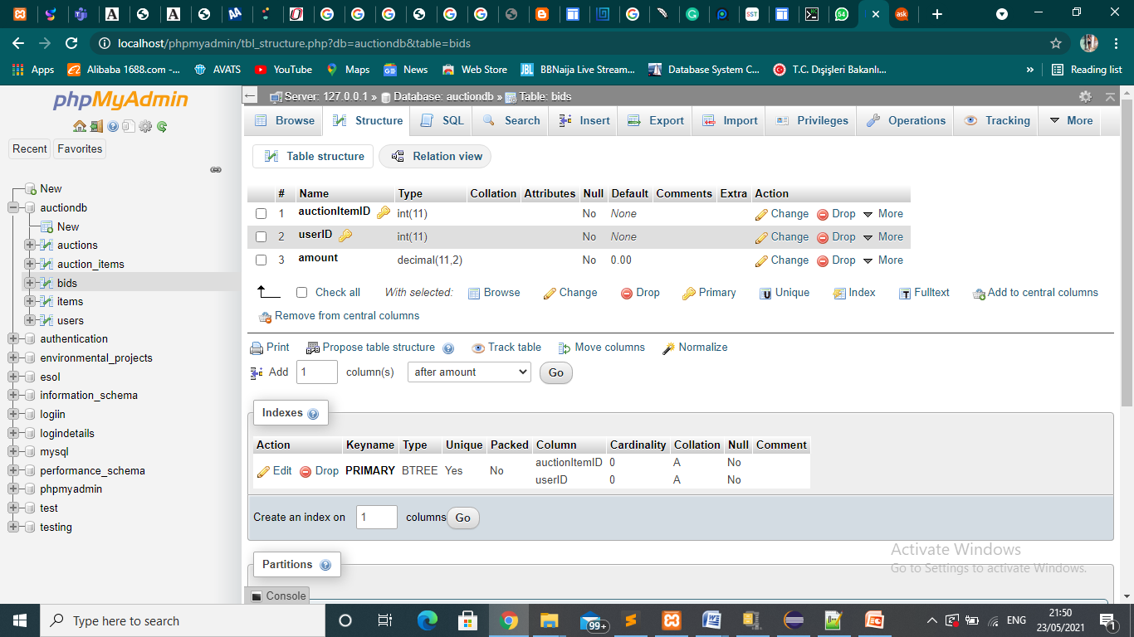

item Table:

This table is used to store the information of all items that is available in the system. It’s from the availability of the items stored here that would determine the item going in for auctions. It consists of 4 columns which are id, name, price and image.

|  |  |
| --- | --- |
| id | int(11) primary key |
| name | varchar(80) |
| price | decimal(11,2) |
| image | varchar(255) |

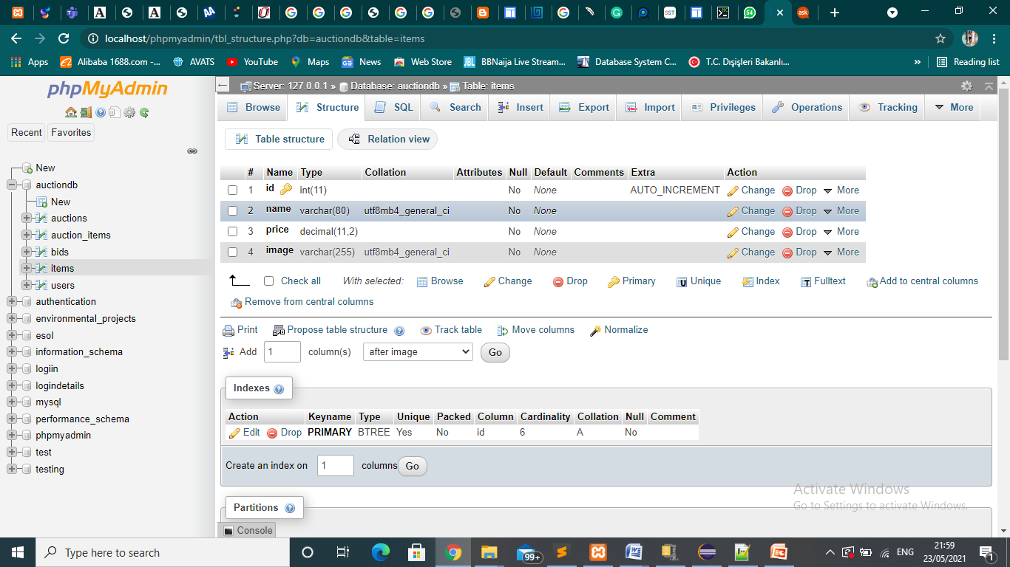

**users Table:**

This table is used to store the information of all registered users in the system. A user inputs this details when registering into the system. It consists of 7 columns which are id, name, email, mobile, address, password and role.

|  |  |
| --- | --- |
| id | int(11) primary key |
| name | varchar(80) |
| email | varchar(80) |
| mobile | text |
| address | varchar(80) |
| password | varchar(225) |
| role | enum(‘user’, ‘admin’) |

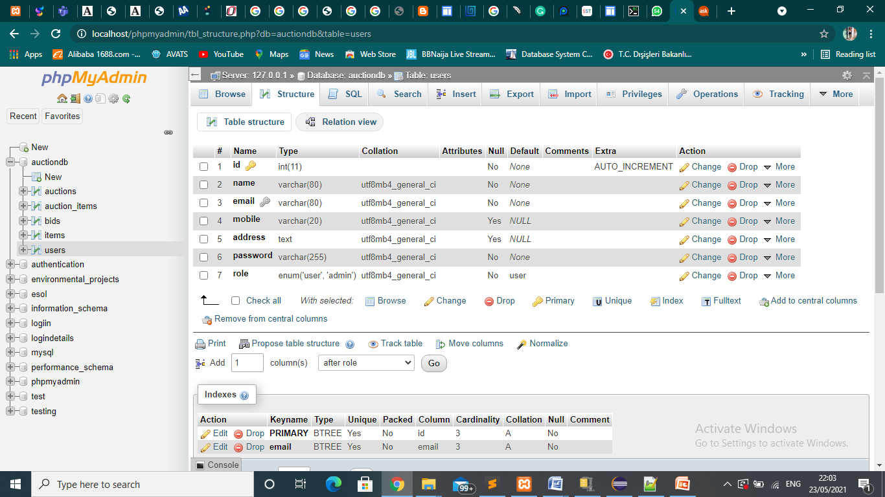

**Architectural Style**

For the architectural style for this system i used a 3-tier system architecture. There are 3 layer involved in the building of this system and they are as follow

Presentation layer

Application layer

Data layer

**Presentation layer**

This is also known as the client layer. It is our system's most advanced layer. When our customers use the app, they see this layer. They can navigate the webpages by using this layer. This layer's primary purpose is to communicate with the application layer. This layer communicates with the application layer the information provided by the user in terms of keyboard actions and mouse clicks.

An example is the home page where our users could see images,texts etc, the login page of our software where our users could see textboxes and button to enter their user id, password and to click in order to have access to the system and other pages like the FAQ, Contact Us page, About Us page and all other pages accessible to both the bidders and the admin.

**Application layer**

This is also known as the logical layer which in this case i am using Xampp. Once the user clicks on any button the application layer interacts with the database layer and sends required information to the presentation layer. This layer acts as a middle man between the presentation layer and the data layer. The whole functionality of our system would be written this layer using sublime text.

**Data layer**

Here is where our application's database is located. To retrieve data from our databases, the application layer interacts with the data layer. It has mechanisms for connecting to the database and performing the required activities. for example when a user needs to update their profile, submit a bid or login.

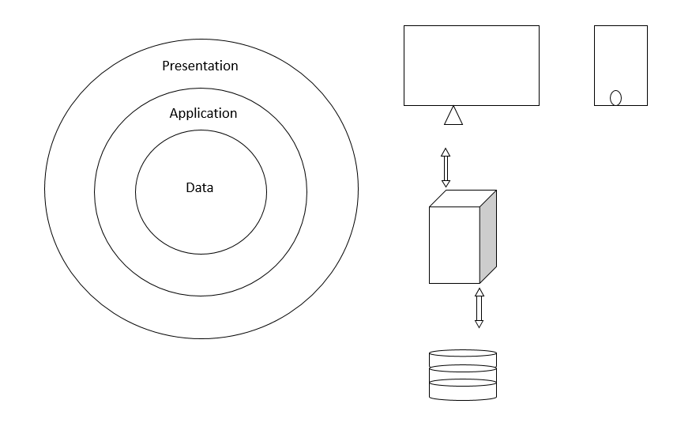

What the user sees when using the app on a mobile phone or in a website

It holds an application layer

It store the data of all our users

**Explanation of Some Codes.**

The idea behind this system online auction is when an auction is live and registered bidders participate, they input their desired price which must be above the start price and the current price. How i made that happen was by writing the php and sql query below.

$id = $_GET['id'];

$sql = "SELECT *, AI.id AS auctionItemID FROM auctions A JOIN auction_items AI ON A.id = AI.auctionID JOIN items I ON AI.itemID = I.id WHERE AI.id = $id";

**For the above query I joined 3 tables which where the auctions, auction_items, and items.**

$result = mysqli_query($con, $sql);

checkError($sql);

$auctionItem = mysqli_fetch_assoc($result);

**This below supervises the price the bidder submits**

if ($_SERVER['REQUEST_METHOD'] === 'POST') {

$amount = $_POST['amount'];

$userID = $auth['id'];

$sql = "SELECT * FROM bids WHERE auctionItemID = '$id' GROUP BY auctionItemID HAVING MAX(amount) ";

**The** **sql query above accepts only maximum amount**

$result = mysqli_query($con, $sql);

checkError($sql);

if (mysqli_num_rows($result) > 0) {

$bid = mysqli_fetch_assoc($result);

if (floatval($bid['amount']) >= floatval($amount)) {

$_SESSION['error'] = "Your bid was not above the highest bid";

header('location: ' . ROOT . '/bid.php?id=' . $id);

exit();

}

}

if ($auctionItem['startPrice'] > $amount) {

$_SESSION['error'] = "Bid cannot be less than starting price";

header('location: ' . ROOT . '/bid.php?id=' . $id);

exit();

}

**The** **sql query below makes it possible for a bidder to re-enter amount to a higher price**

$sql = "INSERT INTO bids (auctionItemID, userID, amount) VALUES ('$id', '$userID', '$amount') ON DUPLICATE KEY UPDATE amount = '$amount'";

$result = mysqli_query($con, $sql);

checkError($sql);

$_SESSION['true'] = true;

header('location: ' . ROOT . '/bid.php?id=' . $id);

exit();

}

$success = null;

if (isset($_SESSION['success'])) {

$success = "Your bid was placed successfully";

unset($_SESSION['success']);

}

**The part which displays the current prices to the screen as they changes is the query below**

$sql = "SELECT * FROM bids WHERE auctionItemID = '$id' GROUP BY auctionItemID HAVING MAX(amount) ";

$result = mysqli_query($con, $sql);

checkError($sql);

$highestBidAmount = 0;

if (mysqli_num_rows($result) > 0) {

$highestBidAmount = mysqli_fetch_assoc($result)['amount'];

}

**In the html part i called the function $highestBidAmount in the div for the current bid and that was how i got it to display the current price as it keeps changing**

<div class="amount-content">

<div class="current">Current Bid</div>

<div class="amount">$<?= number_format($highestBidAmount); ?></div>

</div>

**Timing of the auction**

**I set the timing for each auction to last for 10mins. When an auction is live i created a countdown and by doing this i used javascript and then echoed it using php. Below is the code for it.**

function liveCountDownTimer($auctionItem) {

$startTime = $auctionItem["startTime"];

$id = $auctionItem["auctionItemID"];

$order = $auctionItem['orderNo'];

echo '

<script>

let order = ' . $order . ';

const countDownDate' . $id . ' = new Date("' . $startTime . '").getTime() + (10 * 60 * (order - 1) * 1000) + (10 * 60 * 1000);

const interval' . $id . ' = setInterval(function() {

const now = new Date().getTime();

const distance = countDownDate' . $id . ' - now;

const minutes = Math.floor((distance % (1000 * 60 * 60)) / (1000 * 60));

const seconds = Math.floor((distance % (1000 * 60)) / 1000);

document.getElementById("minutes-' . $id . '").innerHTML = minutes;

document.getElementById("seconds-' . $id . '").innerHTML = seconds;

if(minutes <= 0 && seconds <= 0) {

clearInterval(interval' . $id . ');

}

}, 1000);

</script>

';

}

function isLive($time, $order) {

$time = strtotime($time);

$now = strtotime("now");

return $now <= ($time + (intval($order) * (10 * 60))) && $now >= ($time + ((intval($order) - 1) * (10 * 60)));

}

# Conclusion

The goal of the auction web application is to enable users to be able to bid from their comfort. The project's goals, as mentioned in the introduction, have been achieved. Users which are the admin will be able to upload items for auction once the app is launched, and users here which are the bidders will be able to bid and ultimately buy at a winning bid price.

Meeting the goals set out in the introduction was a fantastic learning experience. It has aided me in the creation of a working system as well as the improvement of my skills which are time management, critical thinking etc.

## Benefits

The benefits of this project to user is listed below

### Benefits to users:

1. To allow user in this case the seller (admin) to be able to get buyers for their product

2. To allow user in this case the bidder to be able to get quality product at their comfort without having to go for life auction

3. It removes the frustration that occurs during live auction for our bidders

4. It saves time as bidders don't have to go to somewhere to compete for the auction.

5. This system is user friendly hence making it really convenient for our users to use.

### Benefits to me:

* + 1. By doing this project i had a deep learning of the language I would be using which is PHP, Javascript, Mysql, Html and Css.
    2. Learning how to develop a working system.
    3. Learnt how to tackle difficulties

## Ethics

The ethics of my project which is an Online Auction System entails the moral principles guiding the functionality of the system and they are listed below

* Since the physical presence of the participant are invisible , there would be 100% honesty and trust of all parties involved in the process
* The items for biding would be accurately evaluated
* Illegal products such as human parts, fire arm would not be auctioned via this system.
* Auctioning past the time frame assigned for each auction would not be allowed.
* An admin shall not be involved in an auctioning
* User either admin or bidders shall not be involved in shill bidding.
* Online only bidding reduces all chances that buyers are exposed to some illegal live bid calling tactics, since there is no live bid calling at an online auction.
* This system makes sure a user cannot register more than once with an already registered email address
* There shall be a clear agreement that whoever wins the bid must pay for the good immediately
* The description that would be provided would be true, accurate and include all necessary charges
* Delivering the goods will be done swiftly after payment

**Why did I choose this project?**

I choose this project because I have always wanted to build a working system an e-commerce one in particular.

The idea that attracted me to this project is the working functionality of this system whereby if a bidders price is greater than the current stated price the current stated price would change to the bidders own.

**You should explain why did you choose these projects, What was the main idea that attracted you to make this project (1-2 paragraph)**

## Future Works

It is impossible to create a system that meets all of the user's requirements. When the system is used, the requirements of the users change. The below are some features that would be added to this system:

* Enable a security framework that uses SSL. That a registered consumer will participate in auctions, win bids, and submit messages, input their username and password which are all important pieces of information. As a result of all this, protecting these data from being intercepted by a third party may be beneficial.
* Include a credit card payment option. It would be ideal if people could pay using their own credit card via this system.
* I would love to add a chat room where a registered user can discuss about the auctions with other registered users
* Lastly i would improve design to enhance better performance and make it more user friendly.

# References

You should write your references which you found at your research and literature survey. You can use APA 6 Format

[1] : Google Sites(2008). *chapter 1 -: introduction - online auction final report*. Retrieved from https://sites.google.com/site/onlineauctionfinalreport/introduction

[2]: BankInfoSecurity. (2008). *Online Auction Safety Part 1: Rules of the Marketplace*. Retrieved from <https://www.bankinfosecurity.com/online-auction-safety-part-1-rules-marketplace-a-743>

[3] : Student Project Guidance & Development(2020). *Online Product Auction System*. Retrieved from https://www.studentprojectguide.com/asp-net/online-auction-management-system/

[4] : 6storage.com (2020). *Pros and Cons of Online Auction Vs On-site Auction: 6Storage*. Retrieved from https://www.6storage.com/pros-and-cons-of-online-auction-vs-onsite-auction/

[5] : StackPath (n.d). *Online bidding problem*. Retrieved from https://www.offshore-mag.com/business-briefs/company-news/article/16756936/online-bidding-solves-some-problems-as-it-creates-others

[6] : (n.d). *Risks involved in Ecommerce for Auctions*. Retrieved from https://www.roseindia.net/tutorial/ecommerce/risks-involved-ecommerce-for-auctions.html

[7] : CactusVPN (2020). *What Is Online Security? (Your Guide to Internet Safety)*. Retrieved from <https://www.cactusvpn.com/beginners-guide-online-security/what-is-online-security/>

[8] [www.academia.edu/9174592/ONLINE_AUCTION_MINI_PROJECT_REPORT.html](http://www.academia.edu/9174592/ONLINE_AUCTION_MINI_PROJECT_REPORT.html)

[9] : Google Books(n.d). Information Security and Ethics: Concepts, Methodologies, Tools, and Applications. Retrieved from <https://books.google.com.cy/books?id=-FbwbCwG5qMC&pg=PA4001&lpg=PA4001&dq=working+ethics+for+an+online+auction+system&source=bl&ots=Wjf6wPbBG4&sig=ACfU3U1jyxzyXjbQ6w38IIkhU-dHND_YeQ&hl=en&sa=X&ved=2ahUKEwjlyrPyra7wAhUShf0HHQTbDroQ6AEwEXoECAUQAw#v=onepage&q=working%20ethics%20for%20an%20online%20auction%20system&f=false>

[10] : All Answers Ltd. (November 2018). Online Auction Management System. Retrieved from <https://ukdiss.com/examples/0410591.php?vref=1>

[11]: Komalah Nair Computing student at Taylor's University College Follow. (n.d.). Class Diagram for online auction system. Retrieved from <https://www.slideshare.net/Komalah/class-diagram-for-online-auction-system>

[12]: UKEssays. (November 2018). Development of Online Auction Management System. Retrieved from <https://www.ukessays.com/essays/information-systems/development-of-online-auction-management-system.php?vref=1>

[13]: Online auction. (2021, April 25). Retrieved from <https://en.wikipedia.org/wiki/Online_auction>

[14]: M&A foundations: Auctions. (2017, July 05). Retrieved from <https://www.seedstars.com/content-hub/learning-resources/m-foundations-auctions/>

[15]: Multitier architecture. (2021, April 28). Retrieved from <https://en.wikipedia.org/wiki/Multitier_architecture#Three-tier_architecture>

[16]: 5 Benefits Of Online Auction Sites. (2018, February 07). Retrieved from <https://www.sudduthrealty.com/5-benefits-online-auction-sites/>

[17]: